**Arrays:**

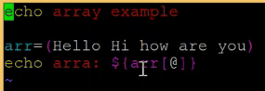

* As above, we have elements inside array and if we want to print all arrays, then we need to use @ inside [ ]
* If we want to print first array, then as below

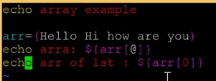

* The index starts with 0
* If we want to print the length of an array, then as below

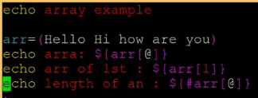

**Deployment automation with shell script:**

* Whenever we are doing deployment, first do the backend deployment
* We can perform the localization before the build itself

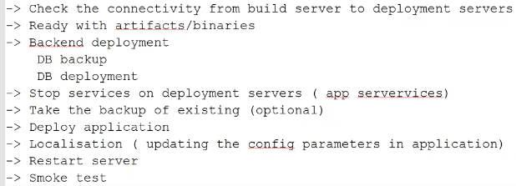

* Whatever the script we write, it is always good to give the details on top of the script as below

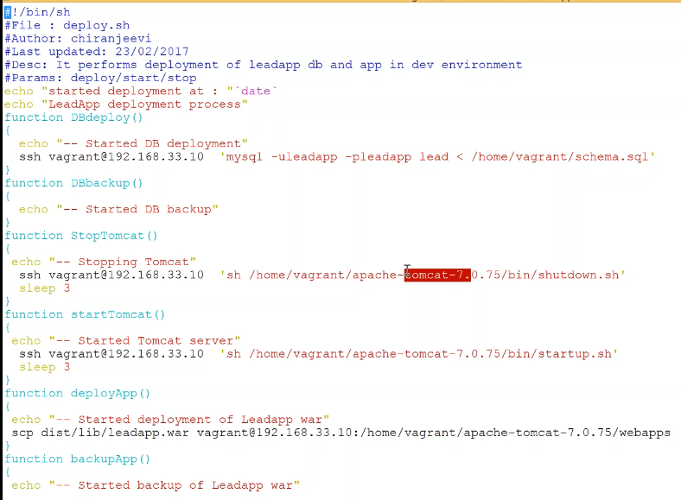

* We can give date at the beginning and at the end also. So that we can get to know when the script started and ended
* Sleep means it will take time gap between running another task
* In reality, we can use variables instead of giving ip addresses and locations. In future if someone wants to change it, they can just change the variables and use it
* As above, we have given all the steps in functions so that we can just call them as below with if switch operation

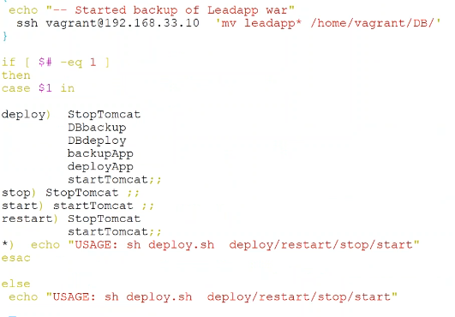

* As above, we can give the instructions as usage if no parameter been called while running the script

